**Conclusions**

1. Film & Video, Music, and Theater are the top three categories. Of all the projects 53% projects succeed, and 37% fail. Although Category Theater has the most successful projects, it also has the most failed projects.

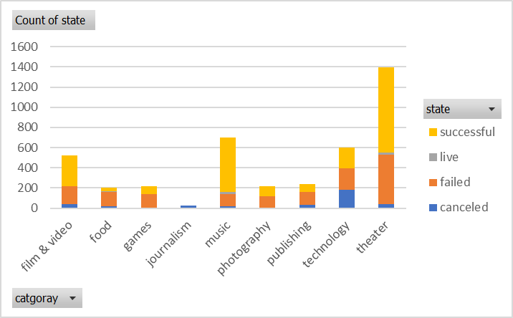

1. The success rate and failure rate of subcategory is varied widely. Rock, documentary, electronic music, hardware, metal, non-fiction, pop, radio and podcast, shorts, television, Sub-Categories has 100% success rate but no of projects is very small. Plays has largest no of projects and success rate is higher than failed rate in plays sub – category.

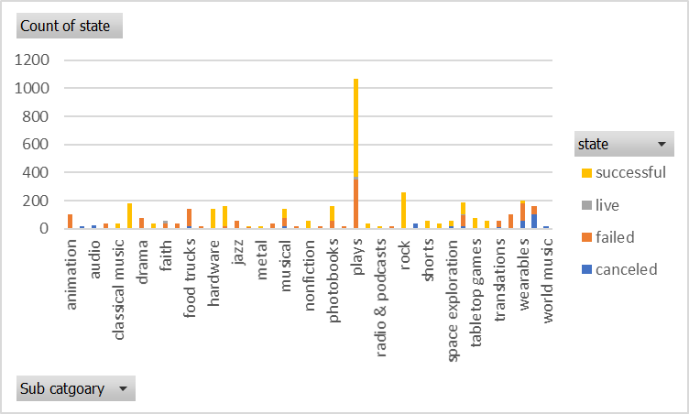

1. Canceled projects counts are consistent over the months. In the month of May most successful projects and after that it started decreasing and in the last month successful and failed cross each other.

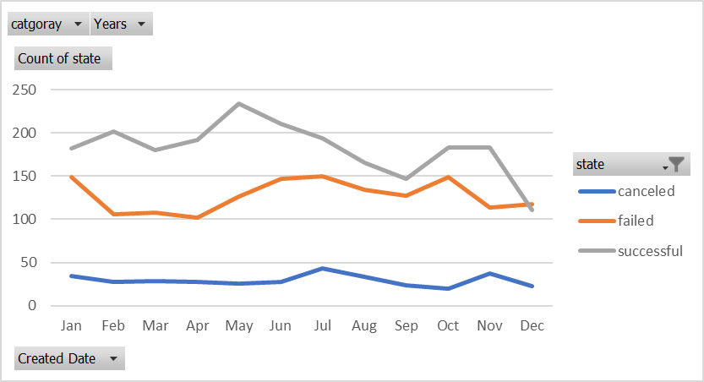

**Some of the Limitations of the Dataset**

* The data set have limited amount sub-categories. The conclusion may not be statistically significant.
* Most of the projects were launched in USA so it could not represent the true picture because of regional limitations.

**Other possible table/graphs**

* Duration to complete the project by success rate and failure rate.
* Pledged amount by success rate and failure rate
* Pledged amount by category and sub-category